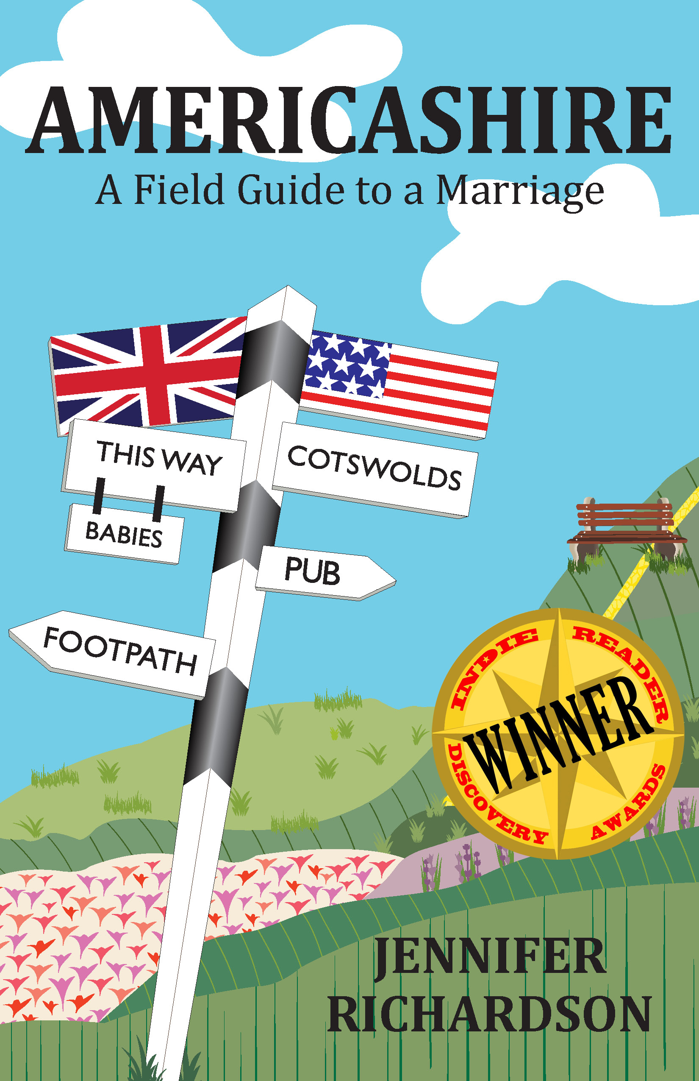
Advance Praise for Americashire

“A wonderfully charming and eclectic take on Britain's Disneyesque Cotswolds by a droll Californian.”
—Adam Edwards, Financial Times and Cotswold Life columnist, London Daily Telegraph writer, and former New York Correspondent for The London Times

“Jennifer Richardson’s beautifully written memoir of her life in a tiny town in the Cotswolds is filled with fabulously eccentric characters, charming episodes, and some serious surprises. The book perfectly captures the hilarious peculiarities of country living with the posh set as well as those of a most unusual marriage.”
—Michael Flocker, author of the best-selling The Metrosexual Guide to Style and The Hedonism Handbook

“In a style reminiscent of Bill Bryson, Richardson turns her wit and keen eye to both the absurdities and the charm of British country life. But, alongside the ludicrous fruitcake auctions and Toff fashion, she also tackles the very serious topics of illness, marriage, and the motherhood decision.”
—Lisa Manterfield, author of I’m Taking My Eggs and Going Home: How One Woman Dared to Say No to Motherhood and Founder of LifeWithoutbaby.com

“Richardson's process of reproductive decision making is as genuine and as circuitous as the country walks she beautifully documents. I recommend this memoir to anyone on the fence or curious about the character and landscape of the childfree life.”
—Laura S. Scott, author of Two is Enough: A Couple's Guide to Living Childless by Choice, and Director of the Childless by Choice Project

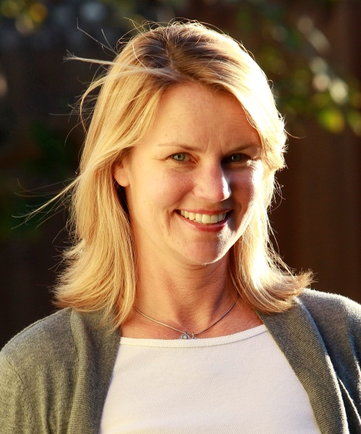
About the Author:
Author photo ©Karl Larsen Photography
Jennifer Richardson is an American Anglophile who spent three years living in a Cotswold village populated straight out of English central casting by fumbling aristocrats, gentlemen farmers, and a village idiot. She is married to an Englishman who, although not the village idiot, provides her with ample writing material. She currently lives in Santa Monica, California along with her husband and her royal wedding tea towel collection.
Find Jennifer online:
www.americashire.com
www.facebook.com/americashire
www.twitter.com/baronessbarren
www.pinterest.com/baronessbarren
Excerpt from Americashire: A Field Guide to Marriage
By Jennifer Richardson
Excerpt from Chapter One: Pink Foil Strips
433 Words

Spring in the Cotswolds happens very slowly and all at once. In exchange for a few cheerful daffodils, the British collectively suspend their disbelief and start to talk of it in March. But spring doesn’t really happen until mid-April on a particular day, when the landscape is dun brown in the morning but by evening you find that green has tipped the balance. Soon lush shag piles of minty-green grass and weeds and shoots and blooms line the country lanes, rising into pea-soup hedgerows, then the brown latticework of trees still bare except for pinch-faced buds. Over the next two weeks, these unwind into a canopy of chartreuse lace, set off by a sprinkling of bluebells on the woodland floor. These are not blue, lavender, lilac, or violet. They are plain purple, the one you get in the Crayola eight-pack.
Rapeseed happens next. Nothing changes the landscape of the Cotswolds more drastically or quickly than the en masse bloom of this flower. It is the color of Ronald McDonald’s jumpsuit or the cheap mustard you get in a plastic packet with your corndog at the beach, a color that should not occur in nature, yet it does. It appears in swathes that render the hills a crude patchwork of yellow and green and drives half the population crazy with its hay-fever-provoking scent. Despite all this, I love it. I love everything about this brash landscape of unrepentant lime-greens and artificial-food-coloring yellows, which is why I start to feel anxious about its demise, almost as soon as I notice it’s happening. Soon May blossom whites and peachy cones of horse-chestnut blooms will be sneaking onto the perimeter, silently upstaging their raucous counterparts with understated elegance. The Cotswolds of Matisse will slip into the diffused light of the Cotswolds of Monet.
Amidst the ephemeral pleasures of spring in the countryside, there was something else to be anxious about. It was wrapped up in a rectangular pink foil strip with twenty-eight pills sealed inside. There were six of those strips to be exact, one for each month of the renewed birth control prescription I had just picked up from the village pharmacy. For the past few months, my husband, D, and I had studiously avoided speaking any further about the “big talk” we had given to my parents over Christmas in which we had announced I was going to try to get pregnant. To be fair, there was plenty to be distracted by in our new country life. But the truth was my ambivalence toward motherhood had not shifted, despite large quantities of fresh air.

