FOR IMMEDIATE RELEASE: MAY 2013
Media Inquiries, Interview or Excerpt Requests
Contact: Eva Zimmerman, Publicist
evalmzimmerman@gmail.com
510.292.8678

Americashire: A Field Guide to a Marriage
A Rural Idyll Memoir for Any Woman Unsure about Having Kids

“A wonderfully charming and eclectic take on Britain’s Disneyesque Cotswolds by a droll Californian.”—Adam Edwards, Financial Times and Cotswold Life columnist, London Daily Telegraph writer, and former New York Correspondent for The London Times

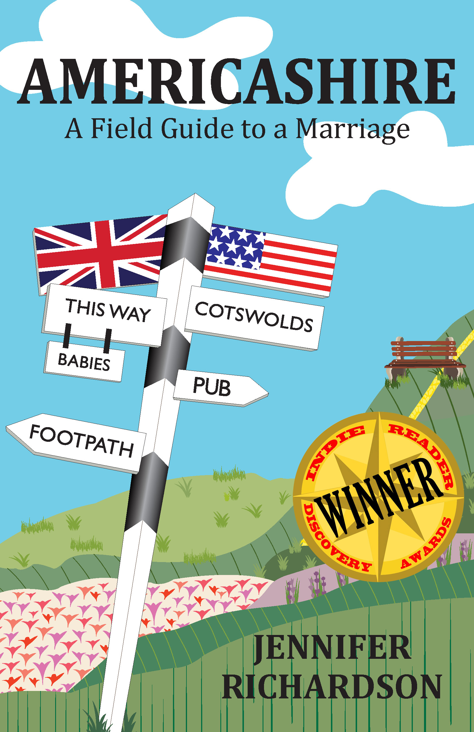
Winner of the 2013 IndieReader Discovery Award for Travel
When an American woman and her British husband decide to buy a two-hundred-year-old cottage in the heart of the Cotswolds, they’re hoping for an escape from their London lives. Instead, their decision about whether or not to have a child plays out against a backdrop of village fêtes, rural rambles, and a cast of eccentrics clad in corduroy and tweed.

Americashire: A Field Guide to a Marriage (She Writes Press/ May 2013/ $15.95) by Jennifer Richardson, begins with the simultaneous purchase of a Cotswold cottage and the ill-advised decision to tell Jennifer’s grandchild-hungry parents that she is going to try to have a baby. As she transitions from urban to rural life, she is forced to confront both her ambivalence about the idea of motherhood and the reality of living with a spouse who suffers from depression. Part memoir, part travelogue – and including field guides to narrative-related Cotswold walks - Americashire is a candid, compelling, and humorous tale of marriage, illness, and difficult life decisions.

"A fine addition to the "English country life" genre, and will thoroughly charm the Anglophilic reader, or any fan of witty slice-of-life commentary. If you like Bill Bryson's travelogues, give this one a try." —Catherine Langrehr for IndieReader

* * *
(over)

“Richardson’s process of reproductive decision making is as genuine and as circuitous as the country walks she beautifully documents. I recommend this memoir to anyone on the fence or curious about the character and landscape of the childfree life.”
—Laura S. Scott, author of Two is Enough: A Couple’s Guide to Living Childless by Choice, and Director of the Childless by Choice Project

About the Author
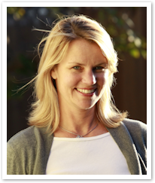
Jennifer Richardson is an American Anglophile who spent three years living in a Cotswold village populated straight out of English central casting by fumbling aristocrats, gentlemen farmers, and a village idiot. She is married to an Englishman who, although not the village idiot, provides her with ample writing material. She currently lives in Santa Monica, California along with her husband and her royal wedding tea towel collection.
Find Jennifer online:
www.americashire.com
www.facebook.com/americashire
www.twitter.com/baronessbarren
www.pinterest.com/baronessbarren
http://www.goodreads.com/book/show/17691662-americashire
Author photo ©Karl Larsen Photography

Americashire: A Field Guide to a Marriage
by Jennifer Richardson
May 2013 | $15.95 | Trade Paper
ISBN: 978-1-938314-30-8 | E-ISBN: 978-1-938314-31-5

About She Writes Press
She Writes Press is an independent publishing company founded to serve members of She Writes, the largest global community of women writers online, and women writers everywhere. We are a curated press that’s both mission-driven and community-oriented, aiming to serve writers who wish to maintain greater ownership and control of their projects while still getting the highest quality editorial help possible for their work.

